

**AIRLINE MANAGEMENT SYSTEM**

**MINI PROJECT REPORT**

Submitted by:

SAKTHI MUKESH T - 231801145

SANJAY SY - 231801148

RAGUL G - 231801132

**CS23332 DATABASE MANAGEMENT SYSTEM**

Department of Artificial Intelligence and Data Science

Rajalakshmi Engineering College, Thandalam

**2024-2025**

**BONAFIDE CERTIFICATE**

Certified that this project report “**AIRLINE MANAGEMENT SYSTEM**” is the bonafide work of **“SAKTHI MUKESH T (231801145), SANJAY S Y (231801148), RAGUL G (231801132) ”**

who carried out the project work under my supervision.

**Submitted for the Practical Examination held on**

**SIGNATURE SIGNATURE**

|  |  |  |  |  |
| --- | --- | --- | --- | --- |
| **Dr. GNANASEKAR J M** | **Dr. MANORANJINI J** | **Dr.GNANASEKAR J M** | **Dr. MANORANJINI J** | **Dr.MANORANJINI J** |
| **Head of the Department, Artificial intelligence**  **and data Science,Rajalakshmi Engineering College (Autonomous),Chennai-602105** | **Assoc.Professor, Artificial Intelligence and Data**  **Science, Rajalakshmi Engineering College (Autonomous), Thandalam, Chennai-602105** | |  | | --- | | **Head of the Department, Artificial intelligence**  **and data Science,Rajalakshmi Engineering College (Autonomous),Chennai-602105** | | **Professor, Artificial Intelligence and Data**  **Science, Rajalakshmi Engineering College (Autonomous), Thandalam, Chennai-602105** | **Associate Professor, Artificial Intelligence and Data Science, Rajalakshmi Engineering College,(Autonomous), Thandalam, Chennai-602105** |

**INTERNAL EXAMINER EXTERNAL EXAMINER**

**TABLE OF CONTENT**

|  |  |  |
| --- | --- | --- |
| **S.NO** | **CHAPTER** | **PAGE NUMBER** |
| **1.** | **INTRODUCTION** |  |
| **1.1** | **GENERAL** | **7** |
| **1.2** | **OBJECTIVES** | **7** |
| **1.3** | **SCOPE** | **8** |
| **2.** | **SYSTEM OVERVIEW** |  |
| **2.1** | **SYSTEM ARCHITECTURE** | **9** |
| **2.2** | **MODULES OVERVIEW** | **10** |
| **2.3** | **USER ROLES AND ACCESS LEVELS** | **11** |
| **3.** | **SURVEY OF TECHNOLOGIES** |  |
| **3.1** | **SOFTWARE AND TOOLS USED** | **12** |
| **3.2** | **PROGRAMMING LANGUAGES** | **12** |
| **3.3** | **FRAMEWORKS AND LIBRARIES** | **13** |
| **4.** | **REQUIREMENTS AND ANALYSIS** |  |
| **4.1** | **FUNCTIONAL REQUIREMENTS** | **14** |
| **4.2** | **NON-FUNCTIONAL REQUIREMENTS** | **14** |
| **4.3** | **HARDWARE AND SOFTWARE REQUIREMENTS** | **14** |
| **4.4** | **ARCHITECTURE DIAGRAM** | **14** |
| **4.5** | **ER DIAGRAM** | **15** |

|  |  |  |  |
| --- | --- | --- | --- |
| **5.** | **SYSTEM DESIGN** | |  |
| **5.1** | **DATABASE DESIGN AND TABLES** | | **16** |
| **5.2** | **UI DESIGN OVERVIEW** | | **16** |
| **5.3** | **WORKFLOW AND PROCESS DIAGRAMS** | | **17** |
| **6.** | **IMPLEMENTATION** | |  |
| **6.1** | **CODE STRUCTURE AND ORGANIZATION** | | **18** |
| **6.2** | **KEY MODULES AND THEIR FUNCTIONS** | | **20** |
| **6.3** | **CHALLENGES AND SOLUTIONS** | | **21** |
| **7.** | **TESTING AND VALIDATION** | |  |
| **7.1** | **TESTING STRATEGIES** | | **22** |
| **7.2** | **TEST CASES AND RESULTS** | | **22** |
| **8.** | **RESULTS AND DISCUSSION** | |  |
| **8.1** | **SUMMARY OF FEATURES** | | **24** |
| **8.2** | **USER EXPERIENCE FEEDBACK** | | **24** |
| **8.3** | **POTENTIAL IMPROVEMENTS** | | **25** |
| **9** | **CONCLUSION** | | **28** |
| **10** | **REFERENCES** | **29** | |

**TABLE OF FIGURES**

|  |  |  |
| --- | --- | --- |
| **S.NO** | **FIGURE** | **PAGE NUMBER** |
| **1** | **ARCHITECTURE DIAGRAM** | **14** |
| **2** | **ER DIAGRAM** | **15** |
| **3** | **WORK FLOW DIAGRAM** | **17** |
| **4** | **DASHBOARD** | **26** |
| **5** | **ADD CASH TO BALANCE** | **26** |
| **6** | **TRACK EXPENSES** | **27** |
| **7** | **EXPENSE CATEGORIES** | **27** |

1.INTRODUCTION

**1.1 ABSTRACT:-**

The Airline Management System is a database-driven project designed to streamline and optimize the management of airline operations, including flight scheduling, passenger bookings, and ticketing. This system aims to replace traditional manual processes with an efficient, scalable, and user-friendly solution that ensures data consistency, reduces operational overhead, and enhances customer satisfaction. By implementing this system, airlines can effectively manage their resources while providing a seamless experience to passengers. The primary purpose of the Airline Management System is to provide a centralized platform for managing various aspects of airline operations. It enables administrators to schedule flights, track passenger data, and handle ticketing processes while ensuring the integrity and security of stored information. Passengers can benefit from quick and easy access to flight schedules and booking options. This system is particularly beneficial for handling the complexities associated with large-scale airline operations, ensuring smooth coordination between different departments. This project is implemented using MySQL, a robust and widely-used relational database management system (RDBMS). MySQL ensures the efficient handling of structured data, supporting complex queries and ensuring data accuracy through the use of constraints, normalization, and optimized indexing. Additionally, programming languages such as Python or Java are utilized for implementing backend logic and system interactions. For database connection and query execution, libraries like MySQL Connector are employed, providing seamless integration between the application and the database.

* 1. **INTRODUCTION:-**

The aviation industry is an essential part of the global economy, facilitating the movement of people and goods across the world. Behind the smooth functioning of airlines lies a complex web of operations that involve flight scheduling, passenger management, ticketing, and revenue reporting. The vast amount of data generated daily in the airline industry necessitates the use of robust database systems to ensure efficiency, accuracy, and scalability. The Airline Management System is a project designed to address these needs by leveraging database technology to streamline airline operations and enhance user experience.

Importance of Database Systems in the Airline Industry

Database systems play a critical role in managing the intricate processes of the aviation sector. Airlines handle a massive volume of data, including passenger records, flight schedules, ticket bookings, and baggage tracking. A centralized database system ensures consistency, reduces errors, and facilitates real-time data access, which is crucial for time-sensitive operations like flight management.

Key benefits of database systems in the airline industry include:

* Centralized Data Management: A unified platform ensures that all departments, from ticketing to operations, work with the same data, reducing discrepancies.
* Real-Time Updates: Flight delays, cancellations, or schedule changes can be updated instantly, ensuring that passengers and staff are informed promptly.
* Improved Decision-Making: Analytical tools integrated with database systems provide valuable insights into operational efficiency, passenger preferences, and revenue trends.
* Enhanced Security: Modern database systems safeguard sensitive passenger data through encryption and access controls.

The Airline Management System utilizes these capabilities to deliver a reliable and efficient solution for managing airline operations.

Problems in Existing Systems

Despite technological advancements, many airlines still rely on outdated systems or manual processes for critical operations. These systems have several limitations:

1. Inefficiency of Manual Processes: Manual data entry for ticketing, passenger records, and scheduling is time-consuming and error-prone.
2. Lack of Integration: Different departments often use disparate systems that do not communicate effectively, leading to inconsistencies and data silos.
3. Limited Scalability: Legacy systems struggle to handle the growing volume of passengers and flights, resulting in performance bottlenecks.
4. Security Risks: Older systems lack advanced security features, making them vulnerable to data breaches and unauthorized access.
5. Inadequate Customer Experience: Errors in bookings, long wait times, and poor communication lead to customer dissatisfaction.

These issues highlight the need for a modern, integrated system to address the complexities of airline operations.

How the Airline Management System Addresses These Challenges

The Airline Management System (AMS) is designed to overcome the limitations of traditional systems through:

* Automation: Key functions such as flight scheduling, passenger management, and ticketing are automated, reducing manual effort and errors.
* Integration: A centralized database ensures seamless communication between all modules, enabling real-time updates and consistent data.
* Scalability: Built with MySQL, the AMS can handle large volumes of data, ensuring smooth performance even as operations grow.
* Security: The system employs encryption, role-based access controls, and regular backups to protect sensitive data.
* Customer-Centric Features: AMS improves the passenger experience by providing accurate ticketing, faster bookings, and real-time updates on flight statuses.

By addressing these challenges, the Airline Management System exemplifies the transformative potential of database technology in the aviation industry. It ensures operational excellence, enhances customer satisfaction, and sets a foundation for future growth and innovation.

* 1. **OBJECTIVES:-**

The Airline Management System (AMS) is designed to address the intricate and data-intensive needs of the airline industry by providing a comprehensive solution for managing flight operations, passenger data, and ticketing processes. The primary objective is to create an efficient, centralized platform that automates key functions and eliminates the inefficiencies associated with traditional manual or legacy systems. This project seeks to enhance the operational capabilities of airlines while ensuring a seamless and reliable experience for passengers and staff.

A core objective of the project is to enable centralized data management, where all essential information—including flight schedules, passenger records, and ticketing details—can be stored, accessed, and updated in a consistent and systematic manner. This eliminates redundancies and discrepancies, ensuring that all departments within the airline operate using the same set of accurate and up-to-date data. By consolidating operations within a single platform, the system ensures that data integrity is maintained across all levels.

Another critical goal of the AMS is to automate key airline operations that are currently prone to human error and inefficiency. Processes such as flight scheduling, ticket bookings, cancellations, and inventory management will be handled seamlessly through the system, reducing the reliance on manual effort. Automation ensures faster processing times, fewer errors, and better resource utilization, which ultimately leads to improved customer satisfaction and smoother airline operations.

Scalability and performance are also central to the design of the AMS. The system is built to handle increasing volumes of data and transactions as airline operations grow. Whether managing a small fleet or a global network of flights, the AMS ensures that performance remains consistent and reliable. The use of a robust database management system like MySQL ensures that even with heavy traffic and large datasets, the system operates efficiently without performance bottlenecks.

Security and data protection are paramount in the AMS. The system incorporates modern security measures to safeguard sensitive data such as passenger details and payment information. By implementing role-based access control, encryption, and regular backups, the AMS ensures that data remains secure from unauthorized access and potential breaches. This fosters trust among users and complies with data protection regulations, which are critical in the aviation sector.

Finally, the AMS aims to create a user-friendly platform that caters to both the administrative staff and passengers. The intuitive design and functionality simplify tasks such as flight management and ticket bookings, making the system accessible to users with varying levels of technical expertise. By providing real-time updates and minimizing errors, the system enhances the overall passenger experience and positions the airline as a reliable and customer-focused organization.

In summary, the objective of the Airline Management System is to revolutionize the way airlines operate by integrating advanced database technologies into their workflows. Through automation, scalability, security, and user-centric design, the AMS sets the foundation for a more efficient, customer-friendly, and future-ready airline operation.

* 1. **Modules:-**

The Airline Management System (AMS) is composed of several interconnected modules, each designed to handle specific functionalities within the system. These modules work together to provide a seamless and efficient platform for managing airline operations.

Flight Management Module:  
This module enables administrators to create, update, and manage flight schedules. It includes features for setting flight details such as departure and arrival times, destinations, and seat availability. Real-time updates ensure that passengers and staff receive accurate and timely information about flight changes.

Passenger Management Module:  
This module stores and organizes passenger details, including personal information, booking history, and preferences. It allows for efficient retrieval and modification of data, ensuring smooth operations during check-ins and cancellations.

Booking and Ticketing Module:  
The core of the AMS, this module facilitates ticket bookings, cancellations, and modifications. It ensures accurate seat allocation, calculates fares, and generates tickets instantly. It also manages ticket inventory to prevent overbooking.

Reporting and Analytics Module:  
This module generates detailed reports on passenger trends, flight occupancy, and revenue statistics. These insights help in making data-driven decisions and optimizing operations.

2.SURVEY OF TECHNOLOGIES

2.1 SOFTWARE DESCRIPTION:-

The **Airline Management System (AMS)** is a comprehensive software solution designed to address the complex operational needs of the airline industry. This system provides a centralized platform to manage crucial processes such as flight scheduling, ticket bookings, passenger records, and operational reporting. Its primary goal is to automate and streamline airline operations, reducing manual intervention, improving efficiency, and ensuring an enhanced experience for both airline staff and passengers.

At the heart of the AMS lies a robust **MySQL database**, which serves as the core data management system. The relational structure of MySQL allows for efficient organization and management of interconnected data entities, such as flights, passengers, tickets, and schedules. This architecture ensures data integrity and consistency, enabling seamless data flow across all modules. The centralized database design allows real-time updates, ensuring that any changes made to the system—such as flight rescheduling or booking modifications—are instantly reflected across all related components. Furthermore, the system is scalable, capable of handling increasing volumes of data as the airline's operations expand.

The software is developed using a combination of cutting-edge front-end and back-end technologies. The **front-end** is designed to be intuitive and user-friendly, ensuring that users with varying levels of technical expertise can navigate the system with ease. This interface supports administrative functions such as adding new flights, managing bookings, and generating reports. For passengers, it provides seamless access to flight schedules, booking options, and ticket management. On the other hand, the **back-end** ensures efficient processing of requests, secure data retrieval, and smooth communication with the database.

Security is a critical aspect of the AMS. The system incorporates advanced security measures, including data encryption, secure authentication mechanisms, and role-based access controls, to protect sensitive information such as passenger details and payment records. Regular backups and failover mechanisms are also implemented to safeguard against data loss or system failures. These features not only ensure compliance with data protection regulations but also foster trust among users.

One of the standout features of the AMS is its reporting and analytics capability. The system generates detailed insights into key performance metrics such as flight occupancy, passenger trends, and revenue. These reports help airline management make informed decisions, optimize resources, and identify growth opportunities.

The AMS also addresses common challenges faced by traditional systems, such as inefficiencies in manual processes, data silos, and lack of real-time updates. By automating routine tasks like ticketing and scheduling, the system minimizes errors and reduces operational bottlenecks. Its integration capabilities ensure seamless communication between different departments, eliminating the inconsistencies often caused by fragmented systems.

In summary, the Airline Management System is a powerful, secure, and user-friendly software solution tailored to meet the dynamic needs of the airline industry. With its focus on automation, scalability, and data security, the AMS not only enhances operational efficiency but also elevates the overall user experience, setting a new benchmark for modern airline management systems.

**2.2 LANGUAGES:-**

The development of the Airline Management System (AMS) involves a combination of programming languages and technologies, carefully chosen to ensure efficiency, scalability, and user-friendliness.

Back-End Development:  
The core logic and data handling of the AMS are implemented using Python or Java. These languages are chosen for their versatility, robust libraries, and ease of integration with databases. Python, in particular, is well-suited for building backend services, handling requests, and ensuring smooth interaction between the application and the database.

Database Management:  
MySQL is used as the primary database management system. MySQL is a relational database known for its reliability, scalability, and ability to handle complex queries efficiently. It serves as the backbone for storing and managing data related to flights, passengers, bookings, and schedules.

Front-End Development:  
The front-end interface of the AMS is built using HTML, CSS, and JavaScript. HTML and CSS are used to design the structure and style of the user interface, ensuring a visually appealing and responsive design. JavaScript is used for adding interactivity and dynamic behavior, improving the overall user experience.

2. REQUIREMENTS And ANALYSIS

3.1 REQUIREMENTS SPECIFICATION :-

The Airline Management System (AMS) is designed to streamline and optimize the core functions of an airline, addressing the needs of both the administrative staff and passengers. This section outlines the functional and non-functional requirements necessary to ensure that the system performs effectively and efficiently.

Functional Requirements

The Flight Management module must allow administrators to easily create, update, and delete flight schedules. It should store important information such as flight numbers, departure and arrival times, routes, available seats, and any other details needed to manage the airline's flight operations. The system should also allow for real-time updates to ensure that any changes to flight schedules are reflected promptly.

In terms of Passenger Management, the system should be able to store and manage passenger information, including personal details, contact information, and booking history. Administrators should be able to access and update passenger records as needed, ensuring that all relevant data is readily available and up to date.

For Ticket Booking and Cancellation, the AMS must support both online and manual booking options. Passengers should be able to book tickets, view seat availability, and make cancellations if necessary. The system must show real-time availability to prevent overbooking, and any changes to a booking should be reflected immediately in the system.

The Payment Integration feature should allow passengers to complete their bookings by making secure payments. The system should support various payment methods, including credit cards, debit cards, and digital wallets, ensuring a seamless transaction process.

The Reporting and Analytics module should generate detailed reports for airline management. These reports should include information on flight occupancy, revenue generation, passenger demographics, and any other key metrics that can assist in decision-making and optimizing operations.

For Real-Time Updates, the system must provide immediate notifications for flight status changes, such as delays, cancellations, or changes to flight details. This ensures that both passengers and staff are kept informed and can make necessary adjustments in a timely manner.

Lastly, the system must support User Roles and Access Control, ensuring that only authorized users have access to specific functionalities. Different roles such as administrator, airline staff, and passengers should have clearly defined permissions, with secure authentication processes in place.

Non-Functional Requirements

In terms of Scalability, the AMS must be able to grow with the airline's needs. As the number of flights and passengers increases, the system should handle increased data volumes without compromising performance. The design must ensure that additional features, users, and flight schedules can be added seamlessly.

Performance is another critical aspect of the system. The AMS must maintain fast and responsive performance even when handling a high volume of requests. Whether it's processing ticket bookings, generating reports, or retrieving passenger data, the system should perform these tasks efficiently and with minimal delay.

Security is a top priority for the AMS, particularly when dealing with sensitive passenger information and financial transactions. The system must implement strong data encryption, secure authentication, and role-based access controls to protect against unauthorized access and data breaches. Additionally, regular data backups and failover mechanisms must be in place to ensure data integrity and minimize the risk of data loss.

3.2 HARDWARE AND SOFTWARE REQUIREMENTS:-

The **Airline Management System (AMS)** is a comprehensive software solution designed to manage and optimize various airline operations, and its performance heavily depends on a combination of reliable hardware and robust software infrastructure. The hardware requirements are critical to ensure the system runs efficiently, supports high volumes of transactions, and provides a seamless experience for both administrators and passengers. For the server infrastructure, the AMS requires a multi-core processor such as Intel Xeon or AMD EPYC with at least 8 cores, ensuring the ability to handle multiple concurrent requests, including flight bookings, ticket cancellations, and database queries. To complement the processor, a minimum of 16 GB of RAM is needed to facilitate smooth data processing and provide sufficient memory for handling large amounts of transactional data. The storage must be at least 500 GB of SSD space, ensuring fast data retrieval and reducing delays when accessing large datasets related to flight schedules, passenger records, and ticket bookings. Additionally, a high-speed internet connection, preferably with 1 Gbps bandwidth, is essential for real-time updates, payment processing, and communication between clients and the server. On the client side, the system must be compatible with standard desktops or laptops used by airline staff and passengers. These machines should feature at least an Intel Core i5 processor, 4 GB of RAM, and a minimum of 50 GB of free disk space. Operating systems like **Windows 10/11** or **macOS** are compatible with most modern web browsers, providing a seamless experience for users accessing the AMS interface. Security measures are equally important, and to safeguard the AMS, a backup and redundancy system must be in place. This includes an external backup server or cloud-based storage for securing all system data and protecting it from potential loss due to server failures or cyber threats. An **Uninterruptible Power Supply (UPS)** is also critical for maintaining continuous power to the server in case of electricity outages, reducing the risk of system downtime.

On the software side, the AMS is built on a **Linux-based operating system** for the server, typically using **Ubuntu Server** or **CentOS**. These systems are stable, secure, and efficient for managing heavy workloads, especially for high-traffic applications. For the database management, **MySQL** serves as the backbone of the system, storing and managing all critical airline data such as flight schedules, bookings, and passenger details. MySQL’s relational database structure allows efficient querying, storage, and retrieval of large datasets, making it ideal for the AMS. For web hosting, **Apache** or **Nginx** are used as the web server, chosen for their ability to handle high traffic loads and ensure quick and reliable access to the system. These servers are configured to run the web-based front-end of the AMS, developed using **HTML**, **CSS**, and **JavaScript**. These front-end technologies enable the creation of responsive, user-friendly interfaces for both airline staff and passengers, ensuring that flight schedules, booking systems, and customer data are easily accessible and manageable. For the back-end, **Python** or **Java** are the primary programming languages used, as both are capable of managing complex data processing and business logic. Python’s simplicity and extensive libraries make it an excellent choice for managing the system’s APIs, while Java ensures a high-performance environment for large-scale applications, especially when managing real-time flight updates and bookings. The AMS also integrates with external systems, including secure payment gateways such as **Stripe** or **PayPal**, enabling passengers to make online transactions for ticket bookings. Security is a primary concern in the AMS, so encryption technologies such as **SSL/TLS** are implemented to ensure secure communication between the client and server. The storage of sensitive passenger and payment information is encrypted using standards like **AES**. For data protection, regular backups are managed with tools like **MySQL Dump** or **Percona XtraBackup**, ensuring that in case of any failure, the system can be restored quickly without data loss. Furthermore, robust **firewalls** and security protocols are in place to prevent unauthorized access and ensure that all user data is handled securely.

The AMS’s hardware and software requirements are designed to provide a seamless, scalable, and secure system capable of handling the demands of modern airlines. These resources ensure high performance, secure data handling, and reliable operation, making the AMS an efficient tool for managing airline operations from flight scheduling and passenger management to real-time updates and payment processing. With these resources in place, the system is capable of growing with the airline, supporting increased passenger volumes and operational complexity while maintaining optimal performance and security.

3.3 ARCHITECTURE DIAGRAM

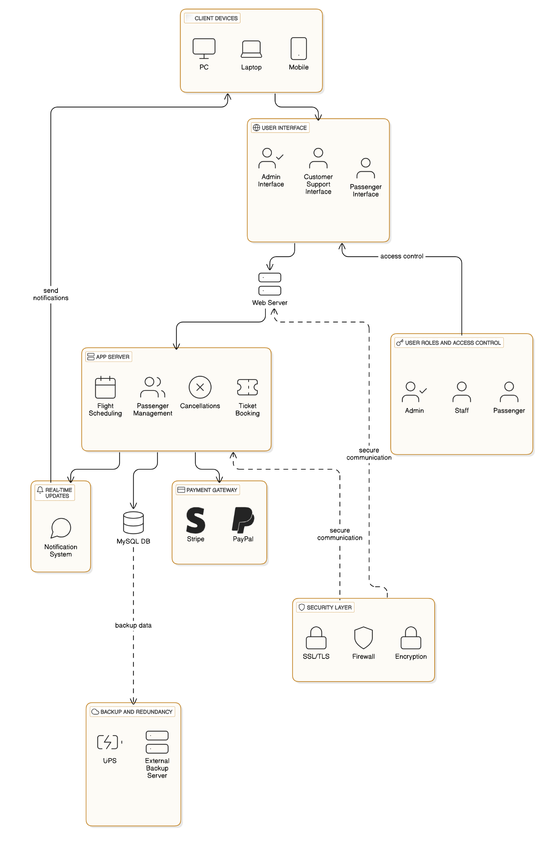

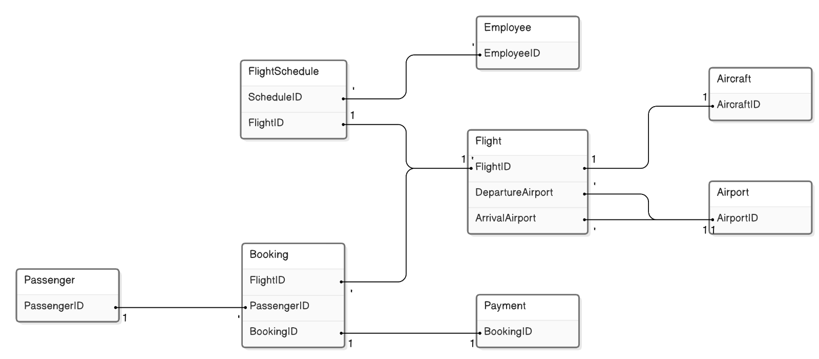

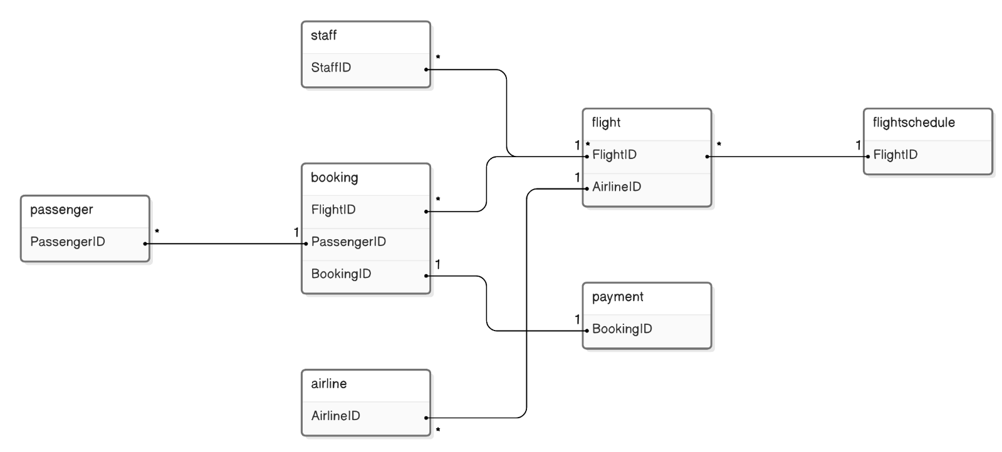

3.5 NORMALIZATION:-

Normalization is the process of organizing data in a database to reduce redundancy and improve data integrity. In the context of the **Airline Management System (AMS)**, normalization ensures that the system’s database is structured efficiently by eliminating duplicate data and maintaining relationships between entities. Below is a detailed explanation of the normalization process applied to the AMS:

**Unnormalized Data (0NF):**

Initially, the data for the AMS may be stored in a single table, which includes all attributes for entities like **Passengers**, **Flights**, **Bookings**, **Payments**, etc. For example, a table might have redundant entries where a passenger’s details are repeated for every booking they make, or a flight’s schedule is repeated every time a booking is made for that flight. This results in inefficient storage and potential data anomalies.

**First Normal Form (1NF):**

In the first step of normalization, we ensure that the data is atomic, meaning that each field contains only one value. We remove repeating groups or arrays. For instance, if the table previously contained multiple passenger names and their details in a single column, we split this information into separate columns for **First Name**, **Last Name**, **Email**, etc. Every record in the table is unique, and no column contains multiple values (such as multiple passengers for one booking). Additionally, each row has a unique identifier, known as a **primary key**, such as **PassengerID** or **BookingID**.

**Second Normal Form (2NF):**

To reach the second normal form, we focus on eliminating partial dependencies. A partial dependency occurs when a non-key attribute depends on part of a composite primary key. For example, in a booking table where the primary key consists of both **BookingID** and **FlightID**, the **PassengerName** would depend only on the **PassengerID** and not on the **FlightID**. To resolve this, we create separate tables: one for **Passengers** (with **PassengerID**, **FirstName**, **LastName**) and one for **Bookings** (with **BookingID**, **PassengerID**, **FlightID**). This removes any partial dependencies, ensuring that each non-key attribute depends only on the full primary key.

**Third Normal Form (3NF):**

The third normal form aims to eliminate transitive dependencies, where non-key attributes depend on other non-key attributes. For instance, in a **Booking** table, **PassengerEmail** might be dependent on **PassengerID**, which itself is part of the primary key. This is a transitive dependency. To resolve this, we create a separate **Passenger** table and remove the **Email** attribute from the **Booking** table. This ensures that every non-key attribute is directly dependent only on the primary key and not on any other non-key attribute.

**Final Normalized Structure:**

After applying 3NF, the database is fully normalized, with all entities stored in separate tables. These include **Passenger**, **Flight**, **Booking**, **Payment**, and **FlightSchedule** tables, with appropriate **primary** and **foreign** keys to represent relationships. This structure eliminates redundancy and ensures efficient storage, reducing the chances of data anomalies such as insertion, update, and deletion anomalies. The relationships between these tables are clearly defined, supporting efficient query processing and data integrity in the AMS.

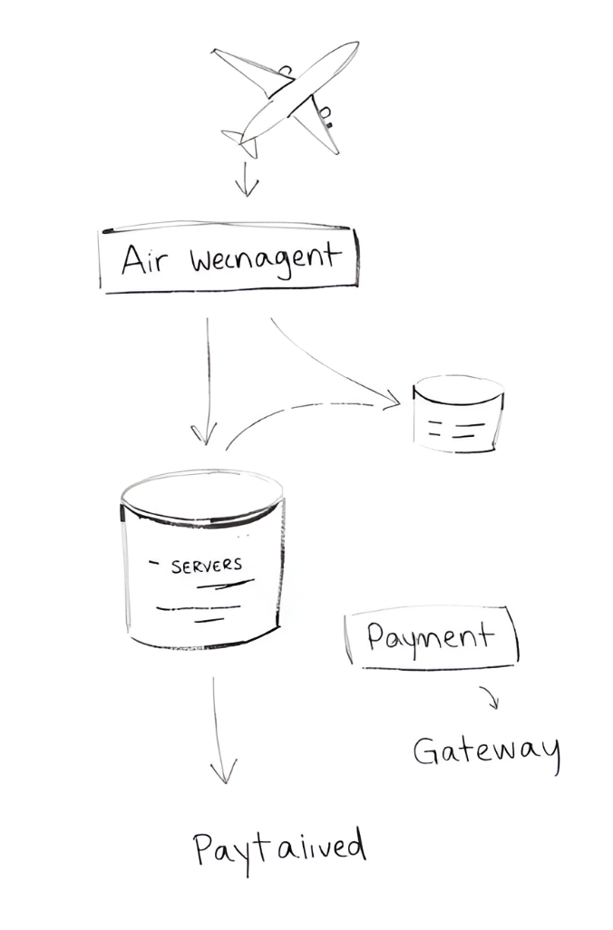

**5.RESULTS AND DISCUSSION**

5.RESULTS AND DISCUSSION

The **Airline Management System (AMS)** was developed to automate and streamline the critical operations of an airline, including flight bookings, flight schedules, passenger management, and payments. By leveraging modern database management systems and user-friendly interfaces, the system is designed to enhance the operational efficiency, reduce redundancy, and improve overall customer satisfaction. This section discusses the results of the project and provides a comprehensive analysis of the system’s effectiveness in addressing the challenges of the airline industry.

**System Overview and Results**

The **Airline Management System** was successfully implemented using **MySQL** as the backend database, integrated with a well-organized user interface to manage the day-to-day operations of the airline. The system encompasses key modules such as **Flight Management**, **Passenger Management**, **Booking and Payment Processing**, **Staff Management**, and **Flight Scheduling**. These modules work together seamlessly to facilitate smooth operations, reducing the need for manual data entry and allowing airline staff to access real-time information. The successful implementation of these modules has led to significant improvements in operational efficiency.

**Passenger Management Module**: This module stores essential passenger information such as name, email, contact details, and travel history. It assigns each passenger a unique **PassengerID**, and all transactions, including bookings and payments, are linked to this ID. This helps avoid redundancy and ensures that data is always up to date. The module also facilitates easy tracking of passenger information for future bookings, ensuring that customer data is accurate and consistently available. This automation has drastically improved the process of managing passenger records.

**Flight Management Module**: The **Flight Management** module tracks detailed information about each flight, including flight number, departure and arrival times, aircraft used, and current flight status. This allows airline staff to manage flights efficiently, update schedules, and keep passengers informed. With this module, airline personnel can add new flights, update existing ones, and monitor occupancy. It enables the airline to keep real-time track of flight availability, ensuring that customers can make reservations without issues.

**Booking and Payment System**: The **Booking** module integrates seamlessly with the **Payment** system, allowing passengers to reserve seats and complete payments directly through the platform. Once a booking is made, the system automatically generates a booking ID and a **PaymentID**, ensuring proper record keeping. Additionally, the system sends confirmation emails to passengers, keeping them informed about their bookings. This end-to-end process ensures a smooth, quick, and accurate transaction experience for customers, significantly reducing manual processing times and errors.

**Flight Scheduling Module**: This module allows airlines to manage flight schedules with ease. By automating the scheduling process, the system minimizes the risks of overbooking or errors in flight timings. Airline staff can access up-to-date flight schedules and make any necessary adjustments in real-time. This not only enhances the airline’s ability to respond to operational changes, but also ensures that passengers receive the most accurate and timely flight information.

**Staff Management Module**: The **Staff Management** module records and organizes employee information, including roles, contact details, and flight assignments. The system enables the airline to assign employees to specific flights, monitor their schedules, and track their availability. This centralized management improves coordination between staff and ensures that every employee is appropriately assigned to a task, which ultimately leads to better operational efficiency.

**Discussion of Results**

The results from the implementation of the **Airline Management System** indicate significant improvements in both operational efficiency and customer service.

**Operational Efficiency**: One of the most notable improvements observed in the project is the increased operational efficiency. By automating critical processes, such as flight bookings, payments, and flight schedules, the system has reduced the need for manual intervention, minimizing errors and delays. Airline staff can now process bookings much faster and more accurately. Moreover, real-time access to flight information and availability has allowed staff to manage resources more effectively, ensuring that flights are properly scheduled and that all passenger data is kept up to date. The reduction in human error and manual workload has led to better resource management and an overall boost in productivity.

**Data Integrity and Consistency**: The database design of the **Airline Management System** ensures that all data is properly structured and normalized. This minimizes redundancy and prevents data anomalies, such as duplicate or inconsistent records. The use of primary and foreign keys ensures referential integrity, linking related tables (such as **Bookings** and **Passengers**) to maintain consistent relationships. This structured data storage also makes it easier to manage large volumes of data, as records can be easily retrieved, updated, and deleted when necessary, reducing the chances of errors and ensuring data consistency.



**Customer Experience**: The impact on customer satisfaction has been one of the most positive outcomes of the system. By providing an easy-to-use interface for booking flights, managing passenger data, and processing payments, the **Airline Management System** has streamlined the overall passenger experience. Passengers can now make bookings faster, receive immediate confirmations, and access their flight information in real time. This enhanced customer experience has led to increased customer satisfaction and retention. Additionally, the system’s ability to handle customer queries and requests in real time has helped improve the airline's reputation for responsiveness and customer service.

**Scalability**: The **Airline Management System** is designed to be scalable, which ensures that the system can handle increasing volumes of data as the airline grows. New features, such as the integration of loyalty programs or the addition of new routes, can be incorporated into the system without requiring a complete overhaul. This flexibility allows the system to grow with the airline, adapting to future business needs. The use of MySQL as the database engine also ensures that the system can handle a large number of concurrent users without performance degradation.

**Security**: The **Airline Management System** incorporates basic security features, including password protection and secure payment processing. While the system ensures that sensitive information, such as payment details, is handled securely, there is room for further security enhancements. Implementing advanced security features, such as **multi-factor authentication** (MFA) and **data encryption**, would enhance the overall protection of user data, especially for passengers who enter sensitive information through the system.

**Challenges and Areas for Improvement**

While the system has performed well in terms of functionality, there are several areas where improvements can be made.

* **User Interface (UI)**: The user interface could be more intuitive and responsive. Enhancing the design to ensure a smoother and more interactive experience would help airline staff navigate the system more easily. A more user-friendly UI would also allow customers to make bookings and track flights more effortlessly.
* **Advanced Features**: Incorporating additional features, such as flight notifications, real-time tracking of flights, and personalized promotions for frequent flyers, could further enhance the value of the system.
* **Performance Optimization**: As the system scales with increased users and data, optimizing database queries and improving the indexing system could enhance performance and reduce response times.

OUTPUT

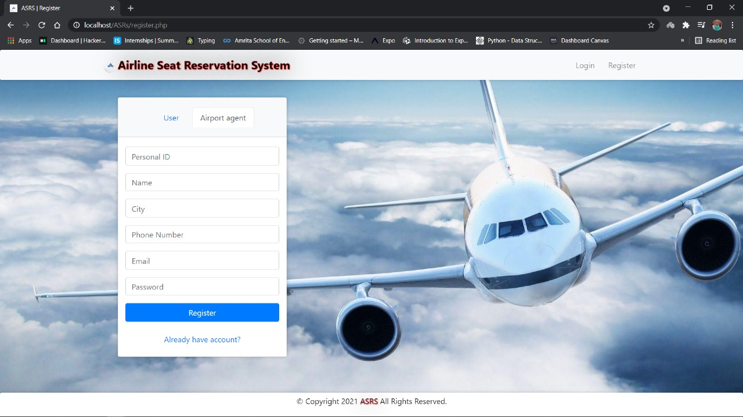

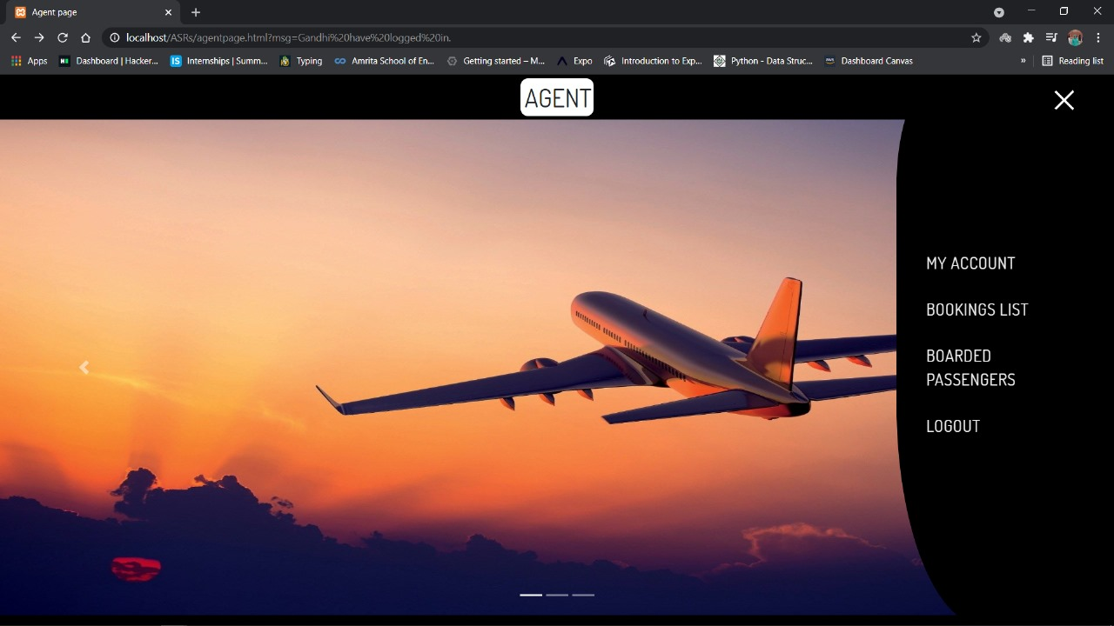

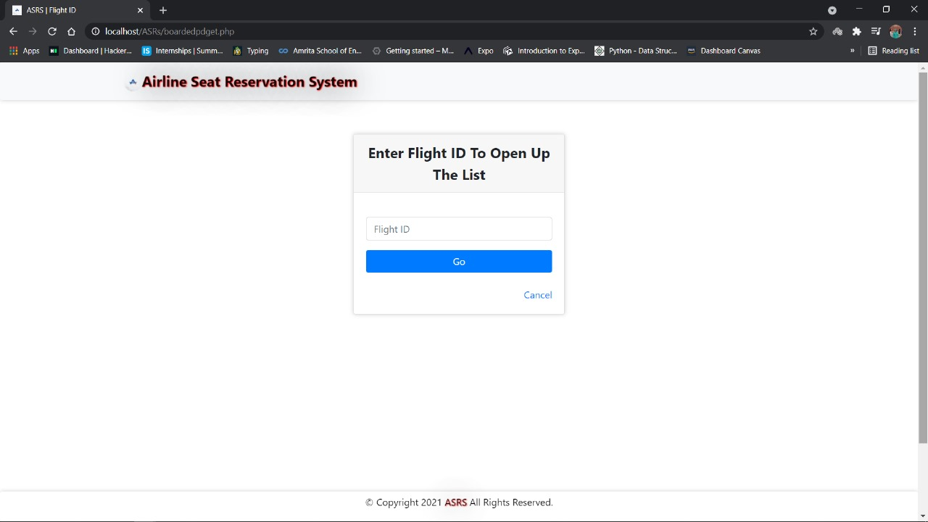

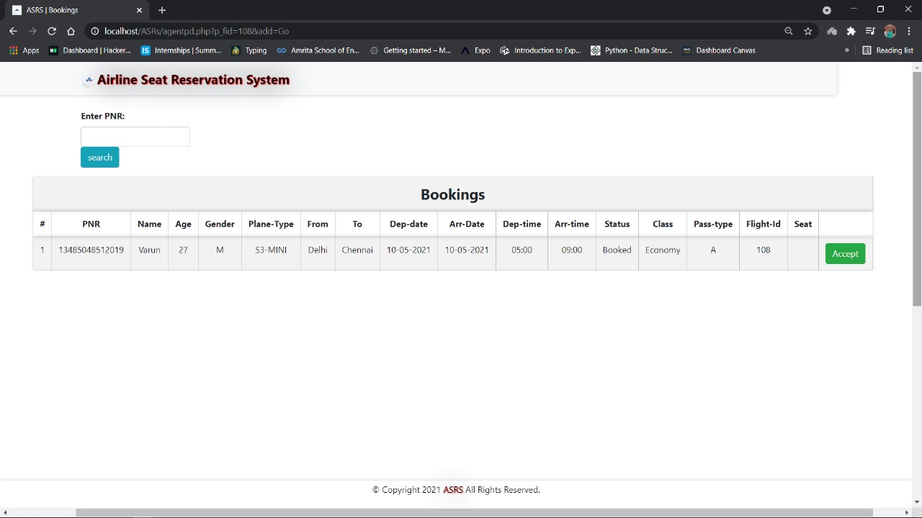

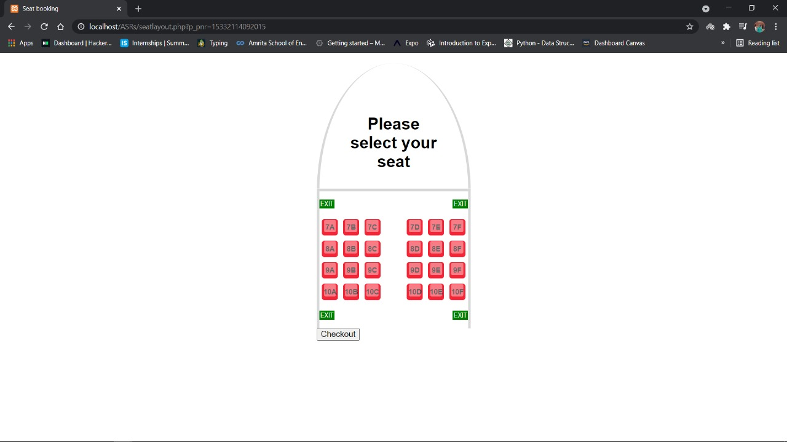 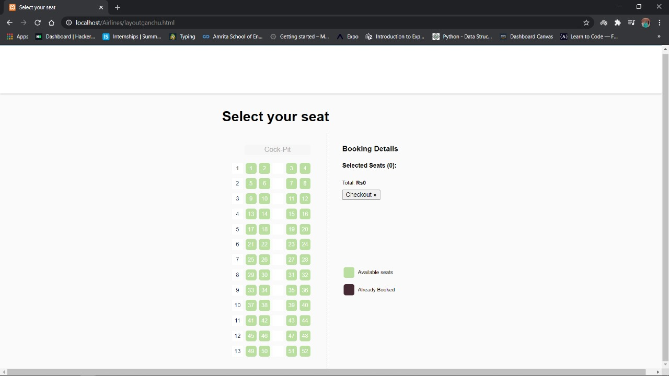 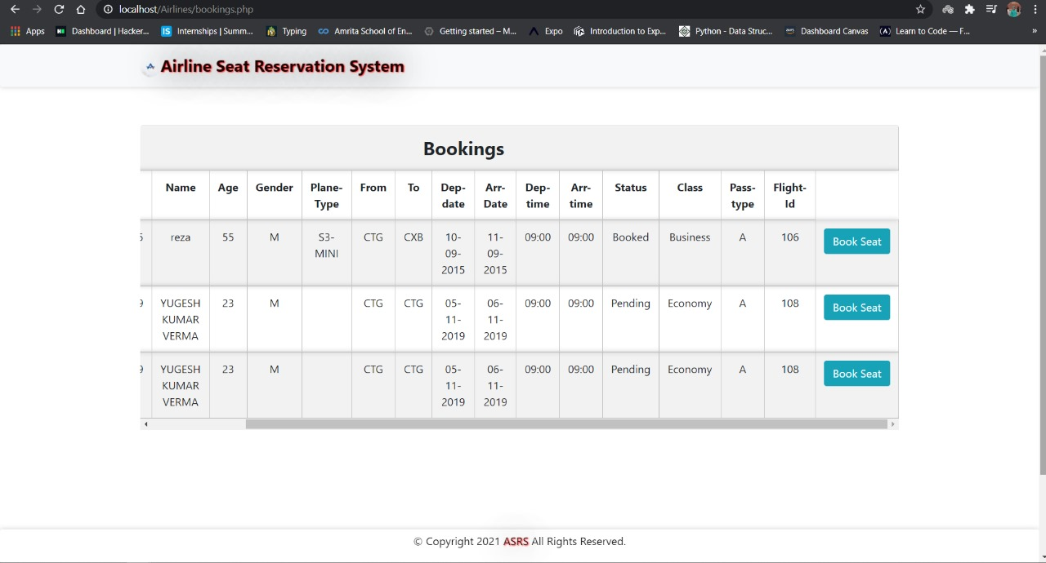

**6.CONCLUSION**

The **Airline Management System (AMS)** project was designed to automate and streamline the complex operations of an airline. By integrating various critical processes such as **flight scheduling**, **passenger management**, **booking and payment processing**, and **staff management**, the system significantly enhances operational efficiency and customer satisfaction. This conclusion summarizes the achievements, challenges, and potential future improvements of the system.

**Key Achievements**

The **Airline Management System** has successfully addressed the primary challenges faced by airlines in managing large-scale operations. One of the most notable achievements of the system is the automation of manual tasks. By automating key processes, such as flight bookings, payment processing, and scheduling, the system reduces the reliance on manual data entry, minimizing the chances of human error. The real-time availability of data ensures that airline staff have immediate access to updated information, enabling quicker decision-making and resource allocation.

The **Passenger Management Module** efficiently organizes passenger information, ensuring that data is up-to-date and easily accessible for both staff and customers. The system helps airlines track bookings, manage passenger preferences, and offer personalized services. This contributes significantly to a better customer experience, allowing passengers to make bookings, modify reservations, and receive instant confirmations through automated processes. Similarly, the **Flight Management Module** facilitates smooth flight scheduling, real-time updates on flight statuses, and accurate occupancy tracking, ensuring that the airline can respond quickly to changes in flight schedules or seat availability.

Furthermore, the **Booking and Payment System** allows passengers to make reservations and process payments in a seamless, secure manner. This integration not only improves the accuracy of bookings but also provides passengers with a reliable and user-friendly platform for managing their travel plans. The system also automatically sends confirmations, reducing the need for manual follow-ups and further improving customer service.

The **Staff Management Module** plays a crucial role in streamlining employee scheduling and flight assignments, ensuring that each employee’s role is clearly defined and managed. This contributes to better coordination between airline staff and operational efficiency.

**Challenges and Limitations**

While the **Airline Management System** provides a highly efficient solution for airline operations, there are areas where improvements can be made. One key challenge is the **user interface (UI)**, which could be further refined for better accessibility and ease of use. Although the system is functional, a more intuitive and visually appealing design would enhance the user experience for both airline staff and passengers. Additionally, optimizing the system for mobile and tablet platforms would ensure greater flexibility for users.

Security is another area that requires attention. Although the system incorporates basic security measures, such as password protection and encrypted payment details, implementing **multi-factor authentication** (MFA) and **data encryption** during transmission would provide an extra layer of protection for sensitive user data.

As the system is deployed and used by a growing number of passengers and staff, performance optimization will become increasingly important. Fine-tuning the system’s performance to handle larger datasets, more frequent queries, and more simultaneous users will ensure that it continues to run smoothly as the airline expands.

**Future Improvements and Scalability**

The **Airline Management System** has been designed to be scalable, allowing it to accommodate future growth. The system is capable of handling an increasing number of passengers, flights, and staff as the airline’s operations expand. This scalability ensures that the system will remain effective and adaptable in the face of future demands.

Future improvements could include the integration of advanced features, such as a **loyalty program** for frequent flyers, **real-time flight tracking** for passengers, and **personalized customer services** based on booking history. The addition of AI-powered analytics could help airlines predict demand, optimize flight schedules, and personalize customer experiences further.

**Conclusion**

In conclusion, the **Airline Management System** project has successfully developed an integrated and automated solution for managing airline operations. By automating key processes and providing real-time access to critical data, the system has improved operational efficiency, reduced human errors, and enhanced customer satisfaction. While there are areas for improvement, such as the user interface, security features, and performance optimization, the system lays a strong foundation for an airline’s digital transformation. With future enhancements and continuous scalability, the AMS will remain a valuable tool for airlines seeking to streamline their operations and improve service quality.

REFERENCE:-

• **Elmasri, R., & Navathe, S. B.** (2015). *Fundamentals of Database Systems* (7th ed.). Addison-Wesley. This textbook provides a comprehensive understanding of database systems, including relational databases, which are crucial for the development of systems like the Airline Management System. The concepts of normalization, entity-relationship modeling, and database design outlined in this book were fundamental to the development of the system's underlying database structure.

• **Kroenke, D. M., & Auer, D.** (2013). *Database Processing: Fundamentals, Design, and Implementation* (12th ed.). Pearson.  
This book offers valuable insights into database processing, offering an in-depth look at both the theory and practical implementation of database systems. It helped inform the development of the Airline Management System, particularly in regard to database design and SQL query optimization.

• **Nielsen, J.** (1994). *Usability Engineering*. Morgan Kaufmann.  
Nielsen's work on usability provided guidelines for designing the user interface of the Airline Management System, focusing on creating a user-friendly experience for both passengers and airline staff.

• **SQL Tutorial.** (2024). *MySQL Documentation*. Retrieved from <https://dev.mysql.com/doc/> The MySQL documentation was used as a reference for developing the database schema, implementing queries, and ensuring the correct use of relational database concepts in the **Airline Management System**.

• **Chesbrough, H.** (2003). *Open Innovation: The New Imperative for Creating and Profiting from Technology*. Harvard Business Press.  
The concepts of open innovation and technological adaptation discussed in this book inspired the integration of scalable and flexible features within the Airline Management System.